**Program 9: Tower of Hanoi**

**Aim**

To write a Python program to solve the **Tower of Hanoi problem** using recursion.

**Algorithm**

1. Start with **n disks** placed on the **source rod**.
2. Define three rods: **Source (A)**, **Auxiliary (B)**, and **Destination (C)**.
3. Base condition:
   * If only 1 disk, move it directly from Source to Destination.
4. Recursive step:
   * Move n-1 disks from Source → Auxiliary using Destination as helper.
   * Move the nth (largest) disk from Source → Destination.
   * Move n-1 disks from Auxiliary → Destination using Source as helper.
5. Repeat until all disks are moved to Destination in correct order.

CODE :

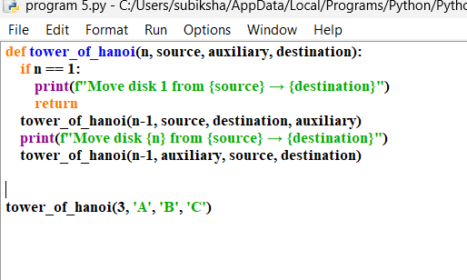

output

